EXAMPLE

8

9

7

2

4

5

8

6

NAME: ___________________________ DATE: _____________________
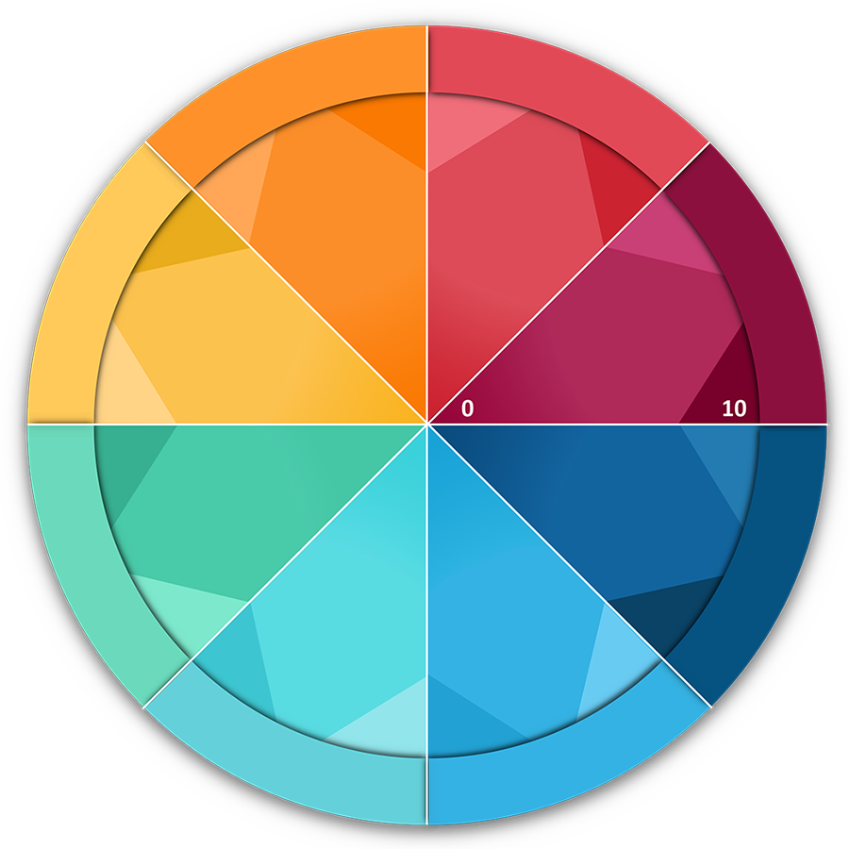

YOUR WHEEL INSTRUCTIONS
The 8 sections in the Wheel of Life represent ________.
- Name the 8 categories so they're meaningful using the space provided in the ring around the wheel.
- Next, draw a line across each segment that represents your satisfaction score for each area.

- Imagine the centre of the wheel is 0 and the outer edge is 10
- Choose a value between 1 (very dissatisfied) and 10 (fully satisfied)
- Now draw a line and write the score alongside (see example above)
- The new perimeter of the circle represents your Wheel of ________. Is it a bumpy ride?

IMPORTANT: Use the FIRST number (score) that pops into your head, not the number you think it should be!

